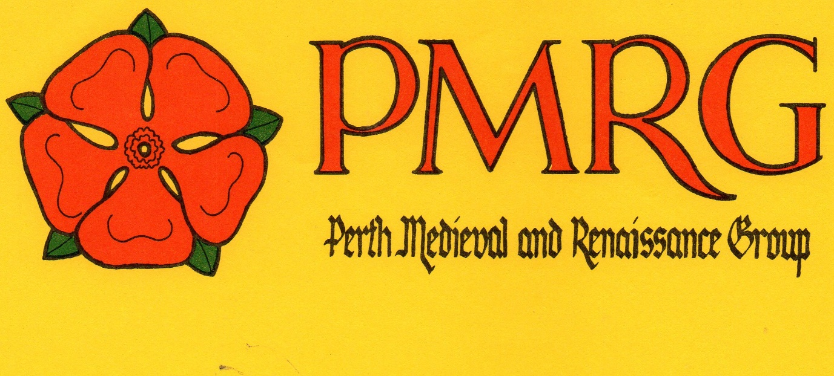

MEMBERSHIP
Name: …………………………………..
Address: ………………………………...
………………………………
Phone: ……………………………..
Email: ………………………………………..
Class of membership – people under 15 years of age are only eligible for Associate membership (please circle): Ordinary Associate
Fee category (please circle): Waged $20 Unwaged $10

Signature:……………………… Date:…………
All membership applications are considered by the PMRG Committee which meets monthly. You will be notified of the outcome and if your application is successful you will be given details of how to pay your fees. Once your fees are paid, your membership of PMRG is confirmed. Please tick this box if you would like a receipt for the payment of fees:
Please email a copy of this form to pmrg.committee@gmail.com

Thank you for your interest in the
Perth Medieval and Renaissance Group

